EU Declaration of Conformity

Hereby we,

Name of manufacturer: | RFE International Ltd
Address: | 8 Clarendon Drive, Wymbush, Milton Keynes, MK8 8ED. UK.
declare that this DOC is issued under our sole responsibility for below equipment:

Product name: | C-24c Bike
Model: | AVUS-10225
Trademark: | adidas
Photo: | 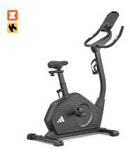
To which this declaration relates is in conformity with the following harmonized standards:

Essential requirements | Standards
Low Voltage Directive (LVD) | 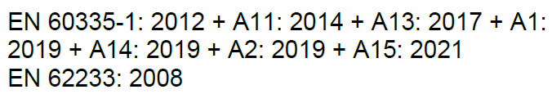
Electromagnetic Compatibility Directive 2014/30/EU  Radio Equipment Directive 2014/53/EU | 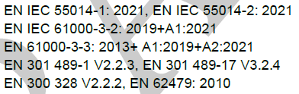

Verification of compliance with certificate no. UKCA GZES2311019805HS issued on 2023-11-30 and UKCA GZCR2311001130HSV issued on 2023-11-24
Signed for and on behalf of | RFE International
Place of issue | Hong Kong
Date of issue | 13th Dec, 2023
Name | Tommy Wong
Position | Compliance Manager
Signature | 