EU Declaration of Conformity

Hereby we,

Name of manufacturer: | RFE International Ltd
Address: | 8 Clarendon Drive, Wymbush, Milton Keynes, MK8 8ED. UK.
declare that this DOC is issued under our sole responsibility for below equipment:

Product name: | SL8.0 Treadmill (DC)
Model: | RVSL-10821
Trademark: | Reebok
Photo: | 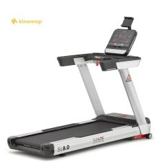
To which this declaration relates is in conformity with the following harmonized standards:

Essential requirements | Standards
Low Voltage Directive 2014/35/EU | 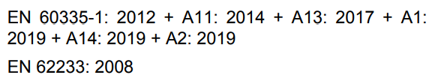
Radio Equipment Directive 2014/53/EU | 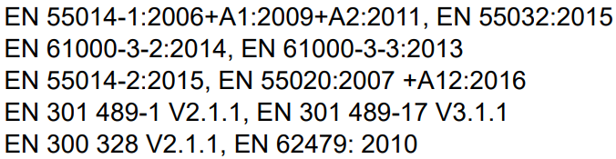

Verification of compliance with certificate no. UKCAGZES2011032496HS issued on 2021-01-27 and UKCA GZEM 2011016645CRV issued on 2021-03-02

Signed for and on behalf of | RFE International
Place of issue | Hong Kong
Date of issue | 17th Nov, 2022
Name | Tommy Wong
Position | Compliance Manager
Signature

