EU Declaration of Conformity

Hereby we,

Name of manufacturer: | RFE International Ltd
Address: | 8 Clarendon Drive, Wymbush, Milton Keynes, MK8 8ED. UK.
declare that this DOC is issued under our sole responsibility for below equipment:

Product name: | C-21 Bike (Bluetooth)
Model: | AVUS-10401BT
Trademark: | Adidas
Photo: | 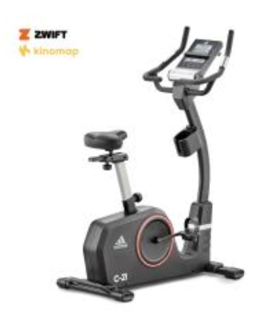
To which this declaration relates is in conformity with the following harmonized standards:

Essential requirements | Standards
Low Voltage Directive 2014/35/EU
Electromagnetic Compatibility Directive 2014/30/EU | 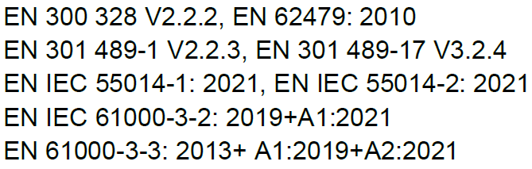

Verification of compliance with certificate no. UKCA GZES2103014194HS issued on 2021-11-22 and UKCA GZEM 2107004749HSV issued on 2021-11-04

Signed for and on behalf of | RFE International
Place of issue | Hong Kong
Date of issue | Mar 6, 2023
Name | Tommy Wong
Position | Compliance Manager
Signature

